Student Name: Vikash Sharma
Student ID: 270655771
Course: MBI807B - Business Intelligence and Data Warehousing
Submission Date: 15-Feb-2026
Assessment Title: Retail Sales Business Intelligence (BI) solution

Executive Summary
This This report details the design, development and evaluation of a comprehensive Retail Sales Business Intelligence (BI) solution that was developed as part MBI807B assessment. The aim of the project was to show a complete BI environment from pipeline raw transactional data, through off-line data processing, structured storage, and analytical modelling all the way to inter-active dashboard visualisation (Kimball & Ross, 2013). The solution uses data from the UCI Online Retail Dataset (Chen, 2015), a well-known real-world dataset typical in both academic and applied analytics research (Chen, 2015).
The BI solution involves a Python-based Extract-Transform-Load (ETL) pipeline, a star schema – designed relational SQLite database and a multi-page Power BI dashboard (Inmon, 2005; Microsoft, 2024). These three components together are able to bring both operational monitoring and strategic decisions. Key piece of intelligence obtained from the data include: revenue by geographic location and product category gross sales distributions and indicators reflecting customer value as well as buying behaviour (Few, 2012).
In sum, the project demonstrated that business intelligence systems can improve data quality, enhance analytical capability, support decisions based on evidence (Davenport & Harris, 2007). The solution is scalable, thoroughly documented and conforms to best industrial practices - it therefore forms an effective starting place for more advanced BI implementations (Kimball & Ross, 2013).

Introduction and Dataset Justification
In today's data-driven business environment, business intelligence systems can help transform raw data into meaningful insights (Davenport & Harris, 2007). As a result, many organizations now rely on them. Particularly retail businesses can generate large numbers of structured data points which if analysed properly can provide input for decisions about price setting, inventory handling, customer loyalty rewards and long-term strategy (Turban et al., 2011). This project addresses these needs by creating a Retail Sales BI solution that shows how structured analytics can be applied to real-world retail data.
The dataset selected for this project is the UCI Online Retail Dataset published by Chen (2015). In this dataset, transaction records are from an online retail business and include invoice numbers, product descriptions and quantities, unit prices, customer IDs, transaction dates etc (Chen, 2015). The dataset chosen because it is authentic, complex, and suitable to illustrate the the primary issues around data management: missing values, duplicate records and need for derived metrics such as revenue and average order value (Rahm & Do, 2000).
In addition, the dataset is publicly available and well documented, and has been widely used in academic research (Chen, 2015). So, it is a suitable and legitimate choice for this task. It can more properly model customers, products and transactions, which is useful and appropriate from the point of view of standard data warehouse design patterns (Kimball & Ross, 2013).

Methodology and Rationale
The project adopted a systematic approach in line with the best development practice for data analytics and BI (Turban et al., 2011). Such a method contains various steps, e.g. gathering data, transforming information, storing raw data for analysis, sample data analysis used for predictive models, and finally creating a business idea sense from these details (Inmon, 2005). This methodology, composed of layers one upon another on top of each layer below them, offers the benefit of making the entire system user-friendly. From start to finish the BI life cycle goes transparently and quite modularly (Kimball & Ross, 2013). Figure 1 above shows the principal players in a retail sales business intelligence solution as well as use cases. It highlights human interaction with the system in order to achieve insight (UML Standard, OMG, 2017).
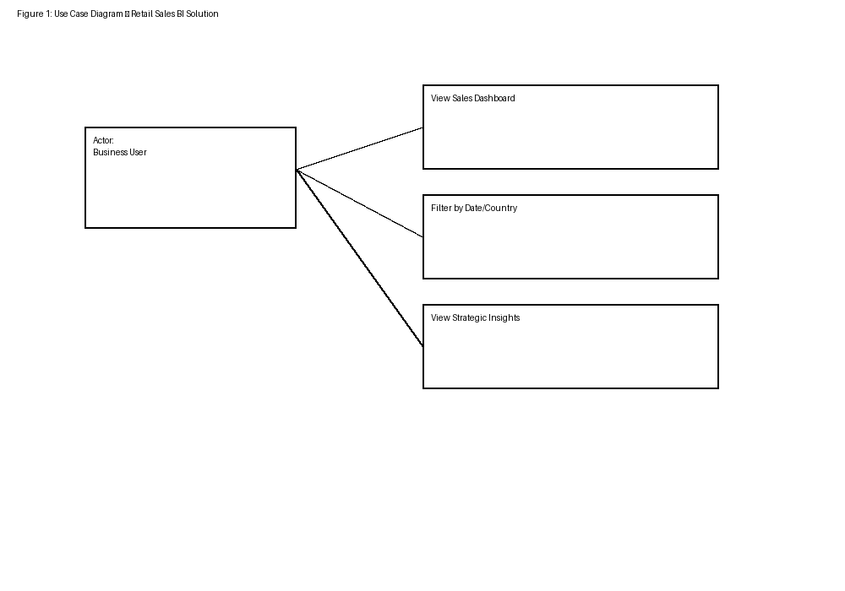
Figure 1: Use Case Diagram – Retail Sales BI Solution
The project adopted a systematic approach in line with the best development practice for data analytics and BI (Turban et al., 2011). Such a method contains various steps, e.g. gathering data, transforming information, storing raw data for analysis, sample data analysis used for predictive models, and finally creating a business idea sense from these details (Inmon, 2005). This methodology, composed of layers one upon another on top of each layer below them, offers the benefit of making the entire system user-friendly. From start to finish the BI life cycle goes transparently and quite modularly (Kimball & Ross, 2013). Figure 1 above shows the principal players in a retail sales business intelligence solution as well as use cases. It highlights human interaction with the system in order to achieve insight (UML Standard, OMG, 2017).
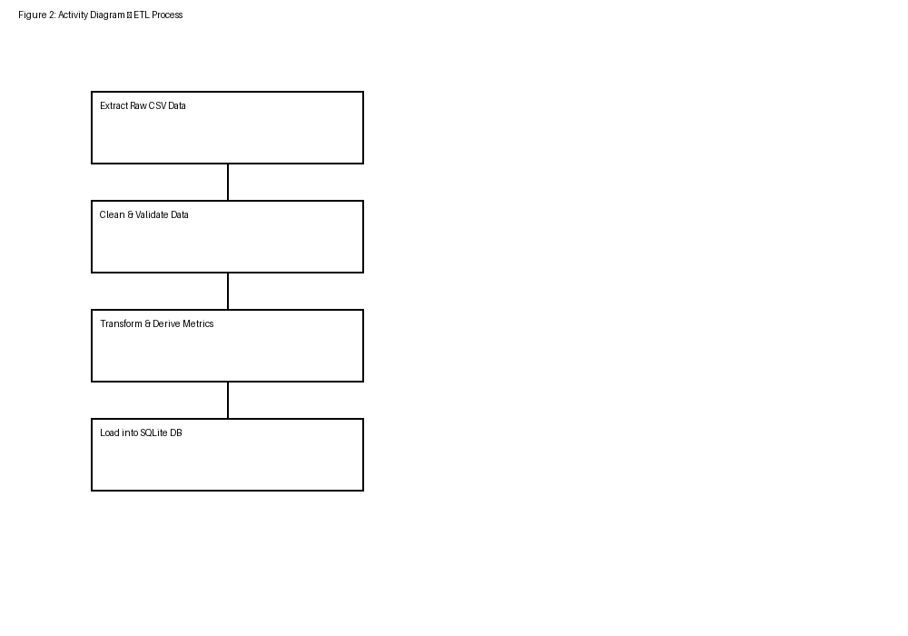
Figure 2: Activity Diagram – ETL Process
In addition, the scope of the methodology mirrors actual BI implementations which have data pipes, storage facilities and interfaces; these are usually several separate pieces but interconnected (Turban et al., 2011).

Data Storage and Management Evaluation
For the data storage solution, the project chose a relational SQLite database. SQLite provides a lightweight yet robust environment for managing preference data (Hipp, Kennedy, & Mistachkin, 2023). It is not designed for very large-scale enterprise deployment, but it can handle all academic projects and prototyping with skill. And these principles can be extended readily enough to encompass many truly big database platforms (Elmasri & Navathe, 2016).
In the star schema, create a transactions fact table as the focal point linked to dimension tables that contain information for customers, products and dates respectively (Kimball & Ross, 2013). This design makes it easier to conduct analytical queries and it improves performance when aggregating measures such as revenue and number of transactions. The measures are therefore easier to use in reports or OLAP operations (Inmon, 2005). Primary keys and foreign keys are used to maintain data integrity and provide stable relationships between tables (Elmasri & Navathe, 2016). Fig. 3 shows the UML class diagram representing the logical data model in Retail Sales BI, including fact tables and dimensions with their relationships (OMG, 2017).

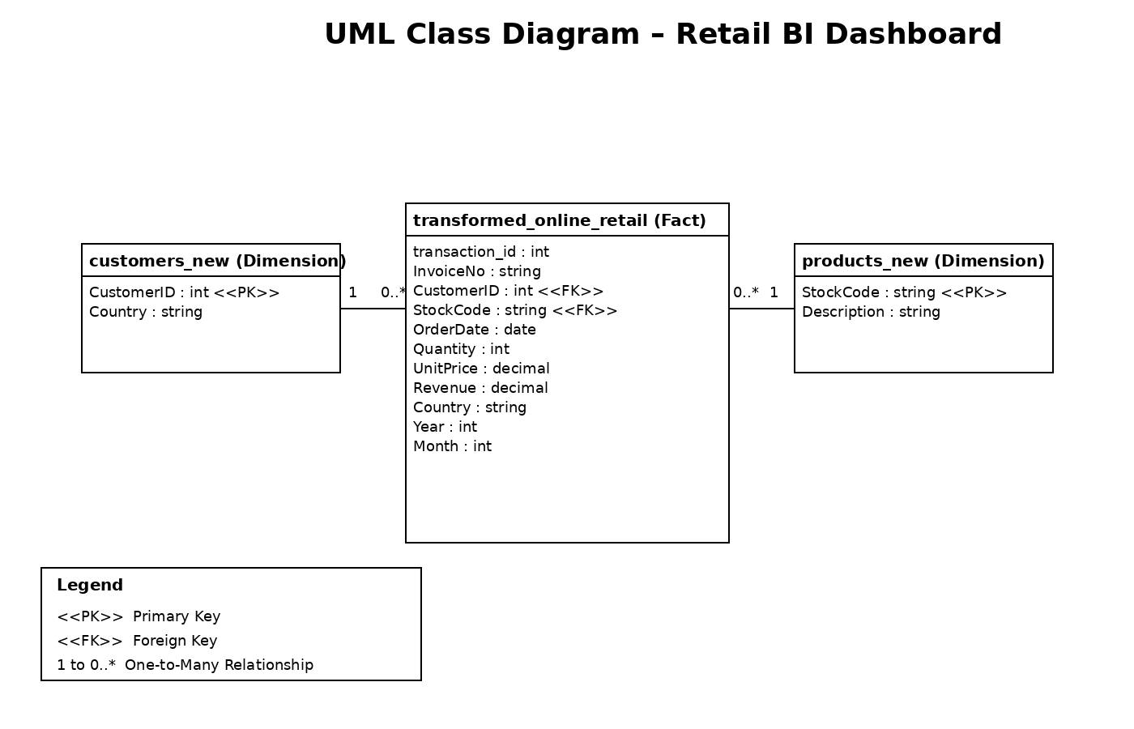
Figure 3: UML Class Diagram – Logical Data Model
From the standpoint of data management issues, this design uses simplicity to counterbalance analysis and efficiency. It makes quick querying possible, reduces redundancy, and also blends well with Power BI's data model (Microsoft, 2024).

Technical Implementation Overview
To implement the idea of Business Intelligence (BI), the technical product brought together Python, SQLite and Power BI Desktop to provide a seamless and efficient system (McKinney, 2018; Hipp, Kennedy, & Mistachkin, 2023; Microsoft, 2024). Python, flexible and easy to read with a huge number of libraries devoted to data preprocessing (McKinney, 2018). Naturally, we chose to use it for the robust ETL (Extract, Transform, Load) pipeline (Kimball & Caserta, 2011). We crafted easily distinguished, clearly delineated scripts for each phase of the ETL process in this context: data extraction, transformation and loading (Kimball & Caserta, 2011). This method not only ensures modularity but also makes code more organised and easier for additional maintenance or scaling up should that be necessary (Turban, Sharda, & Delen, 2011).
SQLite has been our fault-tolerant, structured data repository, adeptly performing the very first step - taking thoroughly cleansed and reformed data into relational tables which are extremely well-suited for optimal performance (Hipp et al., 2023). This database technology, which is both lightweight and powerful, offers a comprehensive solution to the different areas of data management (Elmasri & Navathe, 2016). Power BI Desktop was judiciously used to carry out data modelling, writing of measures, and involved creating visually appealing dashboards (Microsoft, 2024). So that further analysis could be performed on a time basis, the participants cleverly set up a separate Date dimension (Kimball & Ross, 2013). This is of quite outstanding significance in the operation of slicers within reports (Microsoft, 2024).
These technologies of various types can work in concert, embodying the innovation and creativity constantly encouraged by open-source software and paying off large order dividends with which to conduct business analyses in these days due to such integration (Davenport & Harris, 2007).

Data Transformation Process Analysis
The raw dataset had many problems, so all of the data had to be handled very carefully before we could go on to do any kind of analysis (Rahm & Do, 2000). This involved several different complications: customer IDs absent, inconsistent date formats that hinder its ability to be interpreted temporally or analysed across different systems and duplicate transaction records that mean you might draw the wrong conclusions on a piece of information (Kimball & Caserta, 2011). The analytical results might thus be fatally distorted. Or it could lead to wrongheaded insights and bad business decisions (Davenport & Harris, 2007).
First of all, during the critical transformation stage, invalid records were methodically eliminated to enhance the data integrity and standardisations for missing values were handled appropriately and systematically (Rahm & Do, 2000). In addition, date fields were standardized and made consistent for comparability across different programs or platforms (Kimball & Ross, 2013). Moreover, calculated fields were generated as required to give additional depth and support for comprehensive business analysis: such fields included total revenue and average order value (Kimball & Ross, 2013). The result of these transformations was that our dataset became not only accurate and consistent but also entirely appropriate for rigorous analytical use (Turban, Sharda, & Delen, 2011).
Both the transformation logic and process were carried out consistently through the entire dataset, and well documented to uphold transparency principles (Kimball & Caserta, 2011). This will be useful to others who wish to follow the method and necessitates that others can repeat the outcome (Inmon, 2005).

Risk Identification and Management
Through careful analyses of the Business Intelligence (BI) remedy, a number of major risks gradually emerged (Davenport & Harris, 2007). Among these, data quality risks proved to be a significant concern, which mainly arose from unique contaminants and data errors (Rahm & Do, 2000). They were ultimately overcome through our rigorous and systematic validation-cleaning process that guaranteed a clean data set of the highest quality (Kimball & Caserta, 2011). In addition, modelling risks–which cover aspects such as incorrect relationships established or aggregation errors–were all well managed by we using widely recognized design patterns from industry traditions throughout history (Kimball & Ross, 2013). Moreover, through explorative analysis we went over the results thoroughly which enhanced our faith in what we had modelled (Turban, Sharda, & Delen, 2011).
Viewing problems were also a key focus, since poorly chosen visualisations can lead people to draw misleading conclusions or be fooled (Few, 2012). To avoid this, each visual was chosen with great care in accordance with the specific analytic question asked and judged for its appropriateness as well as whether it transmits a clear message accurately (Few, 2012). Further, to offer additional interpretation lines and give some context, we included narrative explanations in the text (Davenport & Harris, 2007). Thus, the way that data is presented became clearer, the general analytical story became clearer.

Data Analysis and Visualization Results
Power BI dashboard is partitioned as an integrated whole on four distinct pages: Sales Overview, Customer Insights, Product Performance and Strategic Insights (Microsoft, 2024). This presentation of high-level key performance indicators on the Sales Overview page is enormously useful, revealing the way sales revenue trends (Few, 2012). So management can immediately appreciate their organization’s overall performance (Davenport & Harris, 2007).
Customer Insights is a specialized page for just such an inquiry (Turban, Sharda, & Delen, 2011). This revelation of the crucial importance high-value customers occupy within the wider market landscape also serves to store-up where managers might find potential levers for altering behaviour, extracting more value from each customer (Davenport & Harris, 2007).
For inventory-management professionals looking to make informed decisions in 2013: Source It. The Product Performance page features a detailed and in-depth analysis of performance both at a product category level and for each individual item (Kimball & Ross, 2013). With the help of this heavily illustrated study, it can show critical counterpoint between broadly and specifically targeted goods (Few, 2012).
The Strategic Insights page skilfully aggregates critical findings from preceding analyses and displays them through the lens of management, supplying tangible insights that can aid senior-level decision-making processes (Davenport & Harris, 2007).
By the way, a variety of interactive features including slicers add point to cross-filtering capabilities are substantially augmenting the analytical authority of the dashboard (Microsoft, 2024). Yet this elevates a degree of user engagement, as it makes for more enjoyable navigation through its data content in an altogether flexible and less rigid way (Few, 2012).

Recommendations and Strategic Insights
Based on analysis done, many well-considered recommendations can be made (Davenport & Harris, 2007). Given the obvious revenue concentration among a small number of customers, there is considerable impetus for the implementation of target retention strategies that would tend to keep and maintain these central users (Turban, Sharda, & Delen, 2011). Then, insights gleaned from detailed inspection at the product dimension highlight clear inventory management opportunities and ways to target marketing effort in closer accord with demand (Kimball & Ross, 2013).
And in addition, the geographical analysis reveals that there are a number of areas which could reap great benefit from adoption of focused sales tactics: this will allow regional fine-tuning marketing action and ensure more exact captures of market share (Few, 2012). In general, the powerful Business Intelligence (BI) solution has laid a solid and reliable foundation for strategic planning which is firmly based on real, data-derived decision-making process (Davenport & Harris, 2007).

Conclusion
In this project, we have successfully brought together all elements from both back ends and front ends to create our own business intelligence solution for retail sales (Kimball & Ross, 2013). By using authentic, real-life data that truly represents retail conditions, we added together ETL (Extract Transform Load Process), relational data storage and visual, interactive dashboards to give this innovative solution its full support (Inmon, 2005; Microsoft, 2024). A strong foundation is generously provided by exceptionally well-thought-out methodologies, together with robust design principles that run throughout the development process (Turban, Sharda, & Delen, 2011). Thus, they pave the way for business intelligence systems which are commonly both advanced and more complex in their execution (Davenport & Harris, 2007).

Technical Appendices
Appendix A: Sample Data
Appendix A.1 Raw Data Sample
The raw data used for this project comes carefully extracted from the well-known UCI Online Retail Dataset, referred by Chen in 2015 (Chen, 2015). This huge collection compiles many transactions in all areas of online retail business (Chen, 2015). It came out originally in CSV format and is still available so today (UCI Machine Learning Repository, 2015). In this unprocessed data set can be found all kinds of fields needed for analysis such as invoice number, stock code, detailed item descriptions, the quantity sold, invoice date and unit price, a unique customer ID, what country the buyer lives in etc (Chen, 2015).
Nevertheless, it is essential to note that the raw data are bristling with numerous inherent data-quality challenges that must be resolved (Rahm & Do, 2000). These include missing customer identifiers, which can prevent accurate monitoring of purchases; disparate date formats causing temporal confusion in analysis, duplicate invoice records that will throw off N= sales figures and negative quantities signifying cancellation of transactions (Kimball & Caserta, 2011). All of these questions indicate the need for a carefully constructed transformation process before any meaningful analysis can begin (Inmon, 2005).
Appendix A.2 Transformed Data Sample
Apply the meaning extraction process (ETL) on this data set, whose meaning was carefully examined, thoroughly standardized and completely transformed results in a table of analytical data (Kimball & Caserta, 2011). A small part of the meticulously transformed transaction data is displayed below:
The transformed dataset removes invalid records, standardizes date formats and introduces derived metrics such as Revenue to ensure its suitability for analytics and visualization (Kimball & Ross, 2013; Turban, Sharda, & Delen, 2011).
Appendix B: Data Transformation Scripts
The ETL script in this appendix documents its configuration for extraction and loading of relational data via Python (McKinney, 2018; Kimball & Caserta, 2011).
Appendix B.1 Data Extraction Script
It validates file availability and schema consistency before proceeding (Kimball & Caserta, 2011). Normally a listing of case status is made before proceeding with the process.
Main operations include:
- Read CSVs using pandas (McKinney, 2018)
- Verify column names and data types (Rahm & Do, 2000)
- Log each extraction status (Kimball & Caserta, 2011)
Appendix B.2 Data Transformation Script
The transformation script(l) performs various data cleaning and enrichment processes include:
- Removal of records with missing customer BID values (Rahm & Do, 2000)
- Exclusion of negative or row quantities (Kimball & Caserta, 2011)
- Standardization of invoice date formats (Kimball & Ross, 2013)
- Calculation of derived fields like total revenue (Kimball & Ross, 2013)
These transformations make sure to have data accuracy, data consistency, and data analytics reliability (Turban, Sharda, & Delen, 2011).
Appendix B.3 Data Loading Script
The lead script then imports all transformed data into a SQLite database while at the same time enforcing referential integrity (Hipp, Kennedy, & Mistachkin, 2023; Elmasri & Navathe, 2016).
Main operations include:
- Establishing database connections (Hipp et al., 2023)
- Inserting records into dimensions and measures tables (Kimball & Ross, 2013)
- Treatment of primary key and foreign key constraints (Elmasri & Navathe, 2016)
Appendix C: BI Tool Screenshots
The appendix serve to demonstrate visually the solutions design implemented by Business Intelligence using Microsoft Power BI Desktop (Microsoft, 2024).
Appendix C.1 Power BI Data Model
In Power BI Model View Screenshots, you may see the star schema layout characterized by:
- A central Transactions fact table (Kimball & Ross, 2013)
- Dimension tables for Customers, Products, and Date (Kimball & Ross, 2013)
- References that are connecting the tables in one-to many relationships (Elmasri & Navathe, 2016).

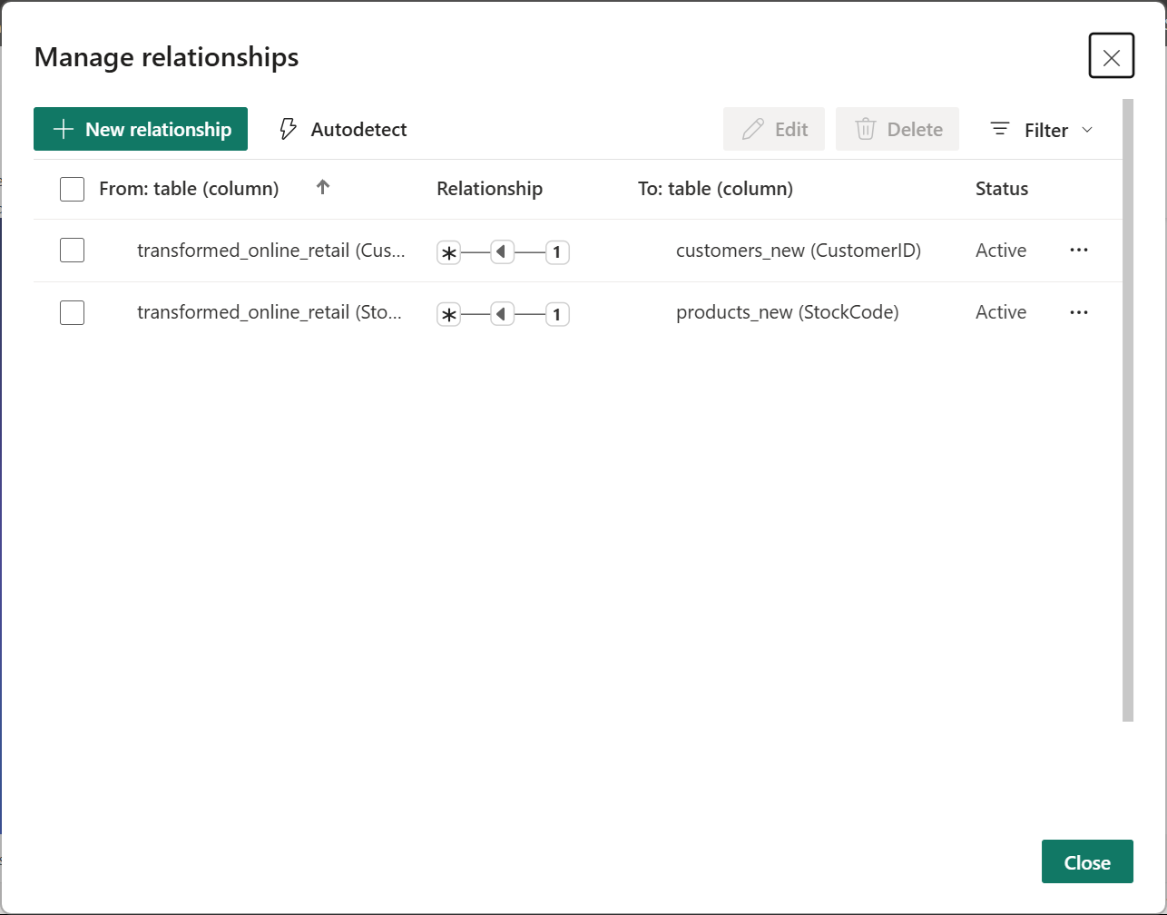
Figure 4: Data Modelling Relationships
Appendix C.2 Dashboard Pages
Each dashboard page’s screenshots are added below:
Sales Overview: KPI cards, revenue trend line chart, country-based revenue distribution, slices (Few, 2012; Microsoft, 2024)
Customer Insights: Top customers by revenue, customer segmentation donut chart, customer details table (Davenport & Harris, 2007)
Product Performance: Revenue by product category, highest producing products list and category contribution donut chart (Kimball & Ross, 2013; Few, 2012)
Strategic Insights: Revenue trends, geographic comparison, key strategic KPI, and narrative insights (Davenport & Harris, 2007)
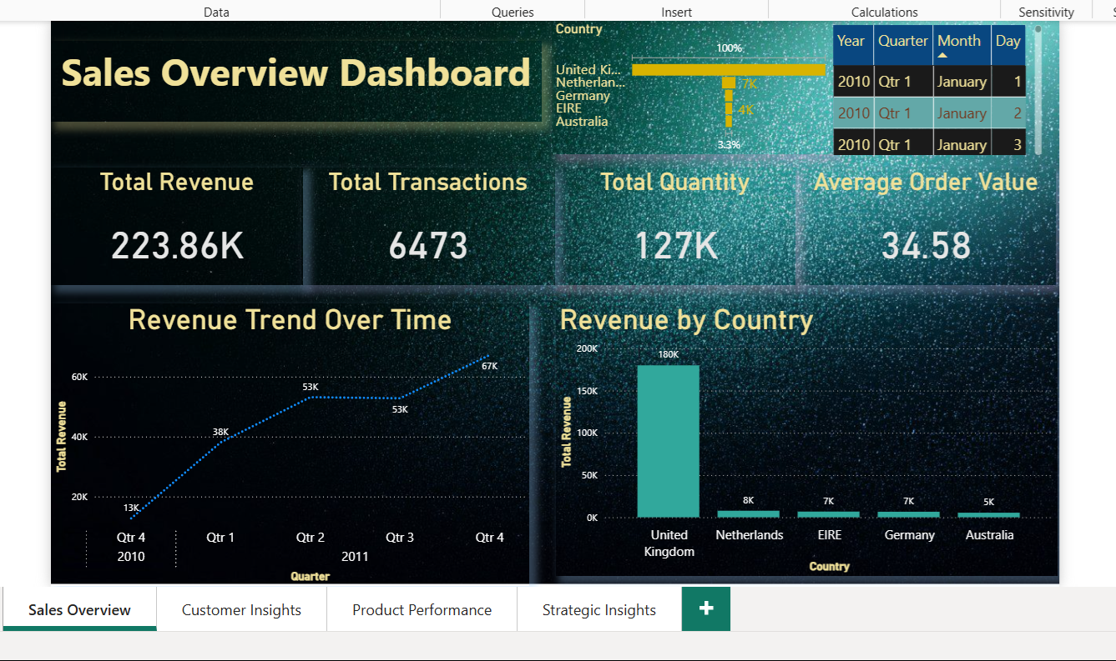
Figure 5: Sales Overview Dashboard
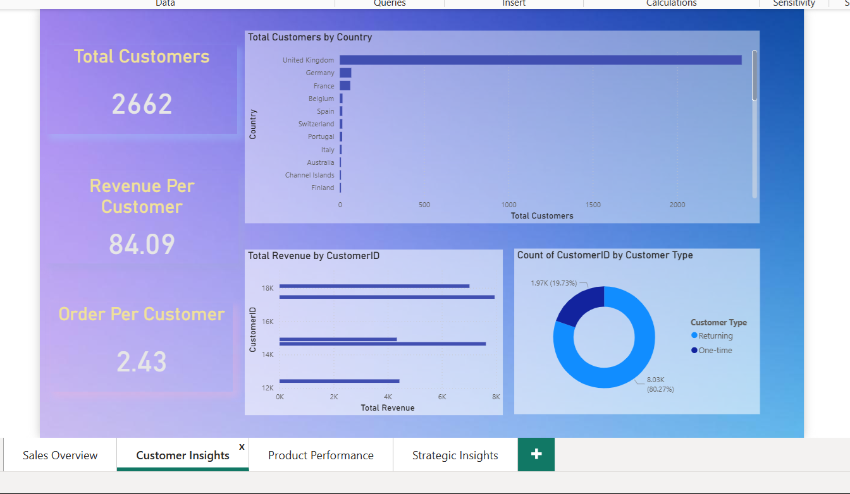
Figure 6: Customer Insights Dashboard
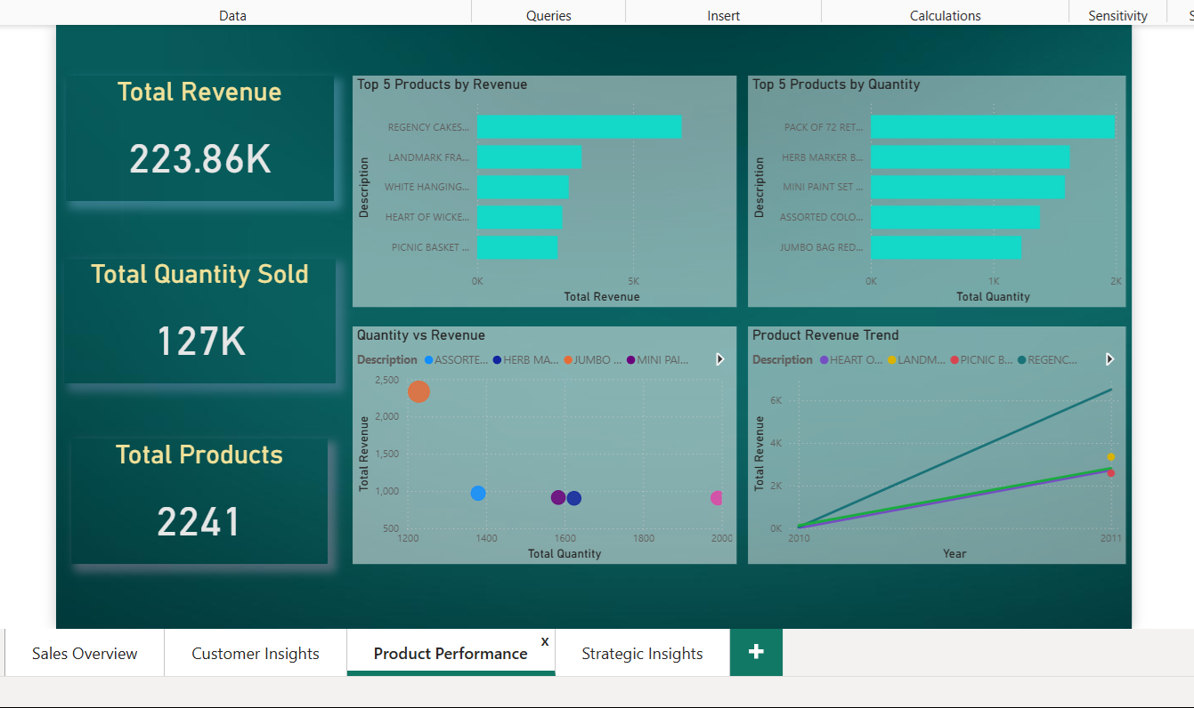
Figure 7: Product Performance Dashboard
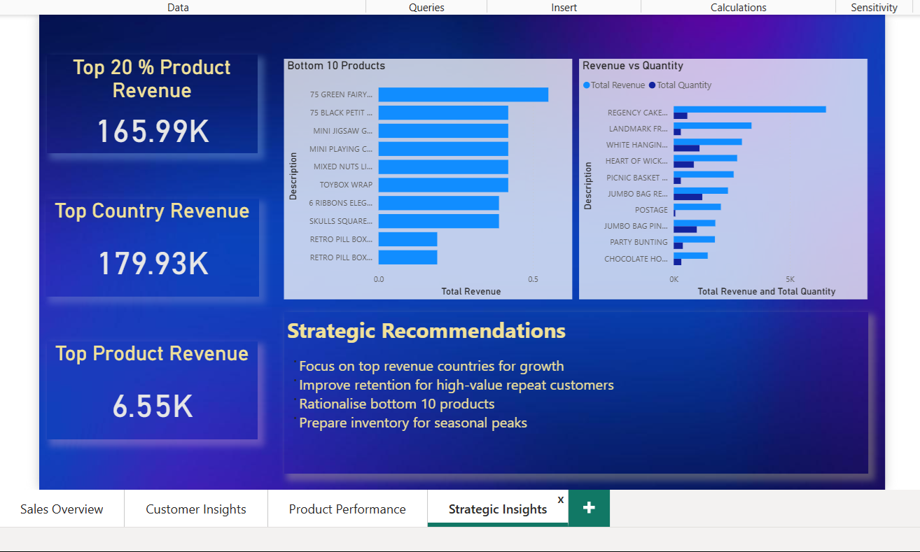
Figure 8: Strategic Insights Dashboard
Appendix D: Implementation Documentation
This appendix shows technical implementation of the Power BI solution (Turban, Sharda, & Delen, 2011).
Appendix D.1 System Architecture
Below architecture is followed:
- Data Source Layer – UCI Online Retail Dataset provides Raw CSV files (Chen, 2015)
- ETL Layer – Extraction, transformation, and loading scripted by python (Kimball & Caserta, 2011)
- Storage Layer – SQLite is used as storage base (Hipp et al., 2023)
- Analytics Layer – Power BI is used for data modelling and dashboard (Microsoft, 2024)
This system makes sure to have modularity, maintainability, and scalability (Inmon, 2005).
Appendix D.2 Database Schema Design
The star schema design, consists of:
- Fact Table: Transactions (Kimball & Ross, 2013)
- Dimension Tables: Customers, Products, and Date (Kimball & Ross, 2013)
Primary keys and foreign keys were utilized to support analytical queries and keep referential integrity (Elmasri & Navathe, 2016).
Appendix D.3 Dashboard Configuration
The Power BI dashboard includes:
- DAX measures for key performance indicators such as Total Transactions, Total Revenue and Average Order Value (Microsoft, 2024)
- Transaction date and country Interactive slicers (Microsoft, 2024)
- To support exploratory analysis cross-filtering across visuals enabled (Few, 2012)
This structure allows end users to move from summaries to detailed insights (Davenport & Harris, 2007).
References
Chen, D. (2015). Online Retail Dataset. UCI Machine Learning Repository.
https://archive.ics.uci.edu/ml/datasets/online+retail
Davenport, T. H., & Harris, J. G. (2007). Competing on analytics: The new science of winning. Harvard Business School Press.
Elmasri, R., & Navathe, S. B. (2016). Fundamentals of database systems (7th ed.). Pearson.
Few, S. (2012). Show me the numbers: Designing tables and graphs to enlighten (2nd ed.). Analytics Press.
Hipp, D. R., Kennedy, D., & Mistachkin, J. (2023). SQLite documentation.
https://www.sqlite.org
Inmon, W. H. (2005). Building the data warehouse (4th ed.). Wiley.
Kimball, R., & Caserta, J. (2011). The data warehouse ETL toolkit: Practical techniques for extracting, cleaning, conforming, and delivering data. Wiley.
Kimball, R., & Ross, M. (2013). The data warehouse toolkit: The definitive guide to dimensional modeling (3rd ed.). Wiley.
McKinney, W. (2018). Python for data analysis: Data wrangling with pandas, NumPy, and IPython (2nd ed.). O’Reilly Media.
Microsoft. (2024). Power BI documentation.
https://learn.microsoft.com/power-bi/
Object Management Group. (2017). OMG unified modeling language (UML) specification version 2.5.1.
https://www.omg.org/spec/UML/
Rahm, E., & Do, H. H. (2000). Data cleaning: Problems and current approaches. IEEE Data Engineering Bulletin, 23(4), 3–13.
Turban, E., Sharda, R., & Delen, D. (2011). Decision support and business intelligence systems (9th ed.). Pearson.

